Lagged cross-correlation: NZDUSD and USDCAD
Method 12 / daily log returns / K_max=10 / Alpari D1 full available history

Study setup
Logical pair: NZDUSD , USDCAD
Broker symbols: NZDUSD_i , USDCAD_i
Snapshot: 2026-11-03_majors_alpari_D1
Timeframe: D1
Matched return window: 1999-01-05 to 2026-11-02 (UTC bar dates)
Matched return count n: 7190
Dropped unfinished last bar dated 2026-11-03 UTC after a tick-volume check against the prior complete day.
Lag definition: rho_X->Y(k) = Corr(x_t, y_{t+k}) on matched D1 bars
K_max = 10; headline lag k = 1 (both directions)
Complete matched rows (Excel): NZDUSD-USDCAD_Lagged_D1.xlsx
Complete matched rows (HTML table): NZDUSD-USDCAD_Lagged_D1_data.html

Method carried forward
Lagged cross-correlation measures Pearson correlation between matched daily log returns of close, ln(close_t / close_t-1), after shifting one series forward by k bars on the matched panel. Quotes are not inverted. rho_{X->Y}(k) = Corr(x_t, y_{t+k}) with n_k = n - k. K_max = 10 is fixed before estimation. The headline is the pre-specified lag k = 1 in both directions. k = 0 is the same-bar side check. The lag inside 1..10 with the largest absolute rho is stored as a descriptive column only; it is not a selected result. This is a linear screen, not proof of forecast edge, economic cause, or a trading signal.

Results (headline k=1)
rho_NZDUSD->USDCAD(1): 0.027254 (n=7189)
95% Fisher interval NZDUSD->USDCAD: [0.004139, 0.050339]
rho_USDCAD->NZDUSD(1): -0.001090 (n=7189)
95% Fisher interval USDCAD->NZDUSD: [-0.024207, 0.022027]
Same-bar rho(k=0): -0.587831
Largest |rho| among k=1..10 (descriptive only, not selected): NZDUSD->USDCAD k=1 rho=0.027254; USDCAD->NZDUSD k=9 rho=0.043205

CCF table
k | rho_NZDUSD_to_USDCAD | n_NZDUSD_to_USDCAD | rho_USDCAD_to_NZDUSD | n_USDCAD_to_NZDUSD
0 | -0.58783124 | 7190 | -0.58783124 | 7190
1 | 0.02725365 | 7189 | -0.00109043 | 7189
2 | -0.00814753 | 7188 | -0.02671036 | 7188
3 | 0.02725218 | 7187 | -0.00668529 | 7187
4 | -0.02089851 | 7186 | -0.02913103 | 7186
5 | 0.01443609 | 7185 | 0.02302918 | 7185
6 | 0.02051677 | 7184 | 0.01785146 | 7184
7 | 0.00514389 | 7183 | -0.00799186 | 7183
8 | -0.00744767 | 7182 | -0.03226067 | 7182
9 | 0.02051665 | 7181 | 0.043205 | 7181
10 | -0.00522872 | 7180 | -0.01109047 | 7180

Conclusion
At the pre-specified lag k=1 for NZDUSD and USDCAD, rho_{NZDUSD->USDCAD}(1) = 0.0273 (n=7189) and rho_{USDCAD->NZDUSD}(1) = -0.0011 (n=7189). Same-bar rho(k=0) = -0.5878. Largest |rho| among k=1..10 is descriptive only: NZDUSD->USDCAD at k=1 (0.0273); USDCAD->NZDUSD at k=9 (0.0432). This is a linear screen, not forecast proof or a trading signal.

Charts
Daily closes

Daily log returns

CCF both directions k=0..10
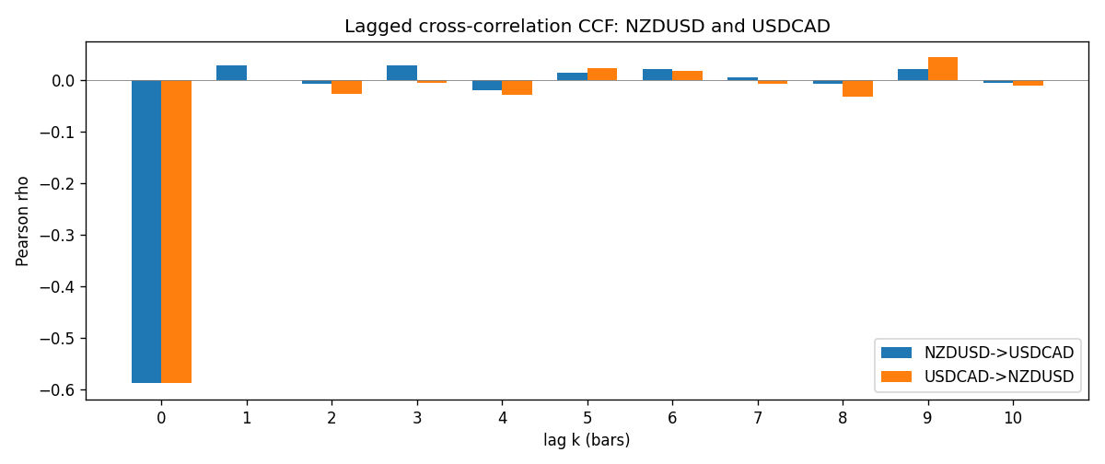

Data report
Every matched row is stored in the sibling Excel workbook named NZDUSD-USDCAD_Lagged_D1.xlsx (sheet matched_rows). The CCF sheet holds rho(k) for k=0..10. Embedding all rows as a Word table is impractical; the Word file holds column summaries and the first and last 15 rows.
Columns: time, NZDUSD_open, USDCAD_open, NZDUSD_high, USDCAD_high, NZDUSD_low, USDCAD_low, NZDUSD_close, USDCAD_close, NZDUSD_tick_volume, USDCAD_tick_volume, NZDUSD_spread, USDCAD_spread, NZDUSD_real_volume, USDCAD_real_volume, NZDUSD_log_return, USDCAD_log_return
Column summaries (matched calculation rows)
column | count | mean | std | min | 25% | 50% | 75% | max
NZDUSD_open | 7190 | 0.6563919 | 0.10821436 | 0.3913 | 0.5912925 | 0.6684 | 0.7249075 | 0.88218
USDCAD_open | 7190 | 1.2668559 | 0.16897553 | 0.9168 | 1.118445 | 1.298545 | 1.37213 | 1.6183
NZDUSD_high | 7190 | 0.66030697 | 0.10871111 | 0.3961 | 0.5947025 | 0.67202 | 0.72936 | 0.88421
USDCAD_high | 7190 | 1.2717549 | 0.16892987 | 0.9336 | 1.122975 | 1.30394 | 1.37655 | 1.619
NZDUSD_low | 7190 | 0.65270307 | 0.10781082 | 0.3897 | 0.5880525 | 0.664185 | 0.720965 | 0.87988
USDCAD_low | 7190 | 1.2623003 | 0.16901312 | 0.9056 | 1.114125 | 1.293585 | 1.36785 | 1.6102
NZDUSD_close | 7190 | 0.65646372 | 0.10821182 | 0.3907 | 0.5915625 | 0.66842 | 0.725015 | 0.8822
USDCAD_close | 7190 | 1.266877 | 0.16895077 | 0.916 | 1.118165 | 1.298615 | 1.372425 | 1.6137
NZDUSD_tick_volume | 7190 | 68672.777 | 123109.57 | 16 | 5561.25 | 33864.5 | 58508 | 1127682
USDCAD_tick_volume | 7190 | 80995.8 | 147287.89 | 37 | 5534 | 40938 | 71622.5 | 1410818
NZDUSD_spread | 7190 | 30.299444 | 25.655426 | 0 | 9 | 17 | 50 | 80
USDCAD_spread | 7190 | 23.448679 | 18.267866 | 0 | 9 | 17 | 40 | 60
NZDUSD_real_volume | 7190 | 1.6692087e+10 | 8.4955308e+10 | 0 | 0 | 0 | 0 | 2.705649e+12
USDCAD_real_volume | 7190 | 1.8371592e+10 | 9.6675129e+10 | 0 | 0 | 0 | 0 | 2.5751613e+12
NZDUSD_log_return | 7190 | 6.02e-06 | 0.00764513 | -0.07027433 | -0.00425619 | 0.00022347 | 0.00457637 | 0.05966839
USDCAD_log_return | 7190 | -9.38e-06 | 0.0051433 | -0.03859748 | -0.00283202 | 5.381e-05 | 0.00272817 | 0.03436319
First 15 matched rows (selected columns)
time | NZDUSD_close | USDCAD_close | NZDUSD_log_return | USDCAD_log_return
1999-01-05 | 0.5372 | 1.5123 | -0.0018597736 | -0.010131666
1999-01-06 | 0.5383 | 1.5118 | 0.0020455609 | -0.0003306769
1999-01-07 | 0.5417 | 1.5141 | 0.0062963171 | 0.0015202092
1999-01-08 | 0.5414 | 1.511 | -0.00055396548 | -0.0020495197
1999-01-11 | 0.547 | 1.5057 | 0.010290425 | -0.0035137769
1999-01-12 | 0.5441 | 1.5157 | -0.0053157489 | 0.0066194721
1999-01-13 | 0.5387 | 1.5226 | -0.0099742238 | 0.0045420214
1999-01-14 | 0.5386 | 1.5332 | -0.00018564931 | 0.0069376546
1999-01-15 | 0.5382 | 1.5245 | -0.00074294208 | -0.0056905671
1999-01-18 | 0.5372 | 1.526 | -0.0018597736 | 0.00098344542
1999-01-19 | 0.5382 | 1.5302 | 0.0018597736 | 0.002748513
1999-01-20 | 0.5404 | 1.5211 | 0.0040793678 | -0.0059646885
1999-01-21 | 0.5426 | 1.5146 | 0.0040627941 | -0.0042823796
1999-01-22 | 0.5361 | 1.5184 | -0.012051689 | 0.0025057712
1999-01-25 | 0.5342 | 1.5197 | -0.0035504102 | 0.00085579808
Last 15 matched rows (selected columns)
time | NZDUSD_close | USDCAD_close | NZDUSD_log_return | USDCAD_log_return
2026-10-13 | 0.56127 | 1.4214 | 0.0047326165 | -0.0046395653
2026-10-14 | 0.55918 | 1.42356 | -0.0037306483 | 0.0015184751
2026-10-15 | 0.56185 | 1.41843 | 0.0047634855 | -0.0036101503
2026-10-16 | 0.56509 | 1.41357 | 0.0057501001 | -0.0034322068
2026-10-19 | 0.56616 | 1.41091 | 0.0018917133 | -0.0018835331
2026-10-20 | 0.56827 | 1.40569 | 0.0037199341 | -0.0037066008
2026-10-21 | 0.57003 | 1.4045 | 0.0030923331 | -0.00084691787
2026-10-22 | 0.56815 | 1.40081 | -0.0033035227 | -0.0026307268
2026-10-23 | 0.56991 | 1.40085 | 0.0030929853 | 2.85545e-05
2026-10-26 | 0.56826 | 1.40093 | -0.0028993932 | 5.7106554e-05
2026-10-27 | 0.56811 | 1.40449 | -0.00026399852 | 0.0025379458
2026-10-28 | 0.56261 | 1.39911 | -0.0097283914 | -0.0038379274
2026-10-29 | 0.56296 | 1.39895 | 0.00062190714 | -0.00011436495
2026-10-30 | 0.56307 | 1.39751 | 0.00019537668 | -0.0010298736
2026-11-02 | 0.56161 | 1.39837 | -0.0025962955 | 0.00061519094

